

PYTHON PROJECT

Project

on

**VOICE ASSISTANT**

Submitted by: Lavanya Puppala

Roll No: 45

Reg.no : 12300764

Course Code: CSM216

Term Id: 224251

Section: K23CH

**Acknowledgment**

I would like to express my sincere gratitude to my instructor, Mr. Aman Kumar Sir, for his invaluable guidance throughout this project. His expertise and advice on both the technical and conceptual aspects of the Voice Assistant have been crucial in shaping its development.

I also extend my thanks to my peers for their constructive feedback, which helped refine the system and improve its functionality, accuracy, and user experience. Their insights have been vital in making the Voice Assistant more practical and user-friendly.

This project would not have reached its current state without the collective effort and support of everyone involved, and I am truly grateful for the encouragement and feedback provided at every stage.

**Table of Contents**

1. Introduction
2. Objectives and Scope of the Project
3. Application Tools
4. Project Design
5. Flowchart
6. Data Flow Diagram

**Introduction**

The "Voice Assistant" project is designed to simplify everyday tasks and provide a seamless interaction experience between users and technology through voice commands. This system acts as a personal assistant that listens to user queries, processes them, and delivers precise responses or performs requested actions. By integrating advanced speech recognition and text-to-speech technologies, the assistant offers a natural, human-like interaction that is both efficient and engaging.

Named "Bittuuu," the assistant can respond to a variety of queries, such as greetings, checking the current time, providing weather updates, playing music, opening applications, or even shutting down the system. Its primary objective is to create a hands-free environment where users can perform tasks quickly without needing manual inputs.

The system’s functionality is built using Python, leveraging powerful libraries such as SpeechRecognition for capturing and processing voice inputs, pyttsx3 for generating voice responses, and requests-html for fetching real-time data like weather information. These tools work together to create a robust and reliable assistant that can handle multiple tasks with ease.

The project also integrates key features such as role-based commands and application control, allowing users to open popular tools like Google Chrome, YouTube, or Instagram with a simple voice command. Additionally, it provides options to play music from local storage or check system settings, ensuring a comprehensive solution for common user needs.

By digitizing and automating routine tasks, the Voice Assistant reduces the need for manual operation, improves accessibility, and enhances productivity. Whether it’s assisting with daily operations or offering an engaging interaction, this system is a step toward creating a more connected and efficient digital experience.

**Objectives and Scope of the Project**

The primary objective of this Voice Assistant project is to create a responsive, user-friendly system that streamlines interactions between users and their devices using voice commands. The assistant, named "Bittuuuu" aims to provide seamless functionality for performing daily tasks efficiently while fostering a more natural human-computer interaction. Key objectives include:

1. **Provide Hands-Free Assistance:** Enable users to perform tasks such as opening applications, checking the weather, playing music, and managing system settings without manual inputs, ensuring convenience and accessibility.
2. **Offer Intuitive Role-Based Responses:** Respond accurately to a variety of user commands, ranging from greetings and time inquiries to application launches and system controls, with personalized and engaging interactions.
3. **Facilitate Real-Time Data Retrieval:** Provide real-time information like the current time and weather updates by integrating APIs and online resources, ensuring accurate and timely responses.
4. **Perform Task Automation:** Execute system-level commands such as opening browsers, shutting down the system, and accessing local applications, helping users save time and effort.
5. **Enhance Entertainment Options:** Play music from local storage or online platforms on request, adding a layer of personalization and entertainment.
6. **Improve Daily Productivity:** Act as a digital companion that supports users in managing their daily tasks, contributing to better time management and overall efficiency.

**Scope of the Project**

The scope of this project extends beyond basic voice recognition, aiming to create a comprehensive digital assistant capable of handling diverse user needs. Although primarily designed for individual users, its structure can be adapted to cater to broader applications, such as smart home controls or professional use cases.

Key functionalities include voice-based command recognition, task automation, real-time data fetching, and interactive responses. The assistant is particularly useful for users seeking a hands-free, efficient way to manage their devices and tasks, providing a robust solution for modern living. This project not only enhances productivity but also introduces a more engaging and interactive way to interact with technology.

**Application Tools**

The successful development of the Voice Assistant project requires a range of tools, libraries, and software to ensure seamless functionality and a user-friendly experience. The tools utilized in this project are as follows:

1. **Programming Language:**
   * **Python:** Serves as the core programming language due to its simplicity, versatility, and extensive library support, enabling efficient development of voice recognition and response systems.
2. **IDE (Integrated Development Environment):**
   * **Jupyter Notebook:** Used during the development phase for testing and debugging individual modules in an interactive environment.
   * **PyCharm:** Employed for integrated development and debugging of the complete application, providing a streamlined workflow.
3. **Libraries/Packages:**
   * **SpeechRecognition:** Used for capturing and processing voice inputs from users.
   * **pyttsx3:** Enables the system to convert text responses into human-like speech for interactive communication.
   * **Requests-HTML:** Fetches real-time data, such as weather updates, from the web.
   * **Pillow:** Handles GUI elements or images (optional for enhancing interaction).
   * **OS and Subprocess:** Used for executing system-level commands, such as opening applications or files.
4. **Version Control:**
   * **Git:** Utilized to track changes in the codebase, facilitate collaboration, and ensure smooth project versioning and rollbacks when needed.
5. **Additional Tools:**
   * **Notepad++:** Used for drafting code snippets, writing pseudo-code, and taking notes during development.
   * **Microsoft Edge or Google Chrome:** Tested as target applications to be opened via voice commands.

These tools work cohesively to build a robust Voice Assistant capable of handling voice-based tasks effectively. By combining Python’s rich ecosystem of libraries with powerful development and debugging environments, the project achieves its goal of delivering an interactive, efficient, and user-friendly assistant

**Project Design**

The Voice Assistant project is organized into several functional modules, each serving a unique purpose to collectively form a cohesive and efficient system. These modules work together to ensure seamless voice-based interactions and task automation:

1. **Voice Recognition Module:**
   * Captures and processes user voice inputs using the SpeechRecognition library.
   * Converts spoken commands into text for further processing.
2. **Command Processing Module:**
   * Categorizes and interprets user commands to trigger appropriate responses or actions.
   * Uses condition-based logic to handle tasks like opening applications, playing music, fetching weather data, or responding to greetings.
3. **Response Generation Module:**
   * Converts system responses into speech using the pyttsx3 library.
   * Provides user-friendly, natural responses to ensure a conversational experience.
4. **Task Automation Module:**
   * Executes system-level tasks, such as opening browsers, playing music, or shutting down the computer.
   * Uses Python’s os and subprocess libraries for process control and automation.
5. **Data Fetching Module:**
   * Retrieves real-time information such as weather updates using the requests-html library.
   * Integrates external APIs to enhance the assistant’s functionality.
6. **Entertainment Module:**
   * Locates and plays music stored on the user’s system or fetches online content based on commands.
   * Provides a personalized experience by accessing local resources.
7. **GUI Design (Optional):**
   * A simple interface can be created using Tkinter for users who prefer visual interaction alongside voice commands.

**Role of Modularity**

This modular design ensures the system is scalable and maintainable. Each module can be individually updated or expanded without affecting the overall architecture. The design focuses on delivering an intuitive, hands-free experience, helping users accomplish daily tasks more efficiently while maintaining a user-friendly and engaging interface.

**Flowchart**

The flowchart below outlines the workflow within the Voice Assistant project, highlighting the key processes and decision points:

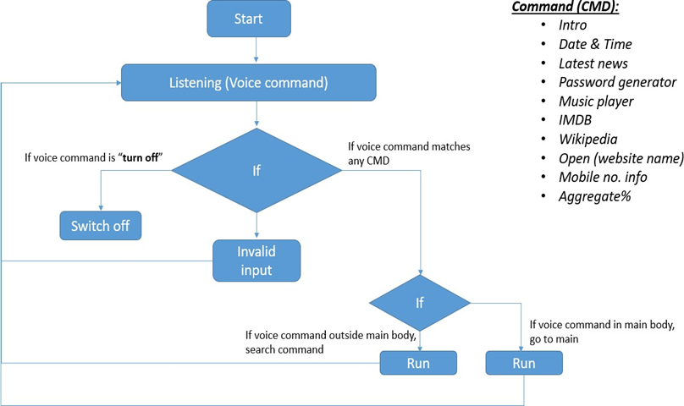

**Data Flow Diagram**

The Data Flow Diagram (DFD) for the Voice Assistant project is structured as follows:

**Level 0 DFD (Context Diagram)**

This level represents the overall system at a high level, showing the main components without detailing internal processes.

* **External Entity:** User
* **Process:** Voice Assistant System
* **Data Flow:**
  + User sends commands (e.g., greeting, asking for time, launching apps) to the Voice Assistant System.
  + Voice Assistant processes the command and sends responses back to the User. 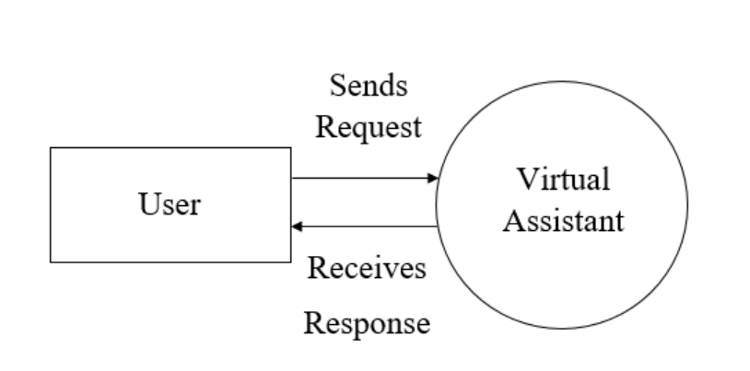

**Level 1 DFD**

This level shows the main processes within the Voice Assistant and how data flows between them.

**Processes**

1. **Voice Recognition**
   * **Input:** User’s voice command.
   * **Output:** Text command sent to Command Processing.
2. **Command Processing**
   * **Input:** Text command from Voice Recognition.
   * **Decision:** Determines the type of command (e.g., response, data fetch, or task execution).
   * **Output:** Sends data or task requests to corresponding modules.
3. **Response Generation**
   * **Input:** Command type (e.g., greeting, name inquiry) from Command Processing.
   * **Output:** Text response for TTS (Text-to-Speech).
4. **Data Fetching**
   * **Input:** Data request (e.g., weather, time) from Command Processing.
   * **Output:** Real-time data sent to Response Generation.
5. **Task Execution**
   * **Input:** System command (e.g., open Google, play music) from Command Processing.
   * **Output:** Executes command and confirms action to Response Generation.
6. **Text-to-Speech (TTS)**
   * **Input:** Text from Response Generation.
   * **Output:** Converts text to speech and provides audio feedback to the User.

**Data Stores**

1. **User Preferences (optional)**
   * Stores personalized user settings for response customization.

**Data Flows**

1. **Voice Command:** Flows from User to Voice Recognition.
2. **Text Command:** Flows from Voice Recognition to Command Processing.
3. **Processed Command:** Sent from Command Processing to either Response Generation, Data Fetching, or Task Execution.
4. **Real-Time Data:** Flows from Data Fetching to Response Generation.
5. **Action Confirmation:** Sent from Task Execution to Response Generation.
6. **Audio Response:** Generated by TTS and provided back to the User.

**BLOCK DIAGRAM:**

